**DEPLOYMENT STRATEGY**

1. Make sure that all the Audit policies required are turned on to all the client computers.

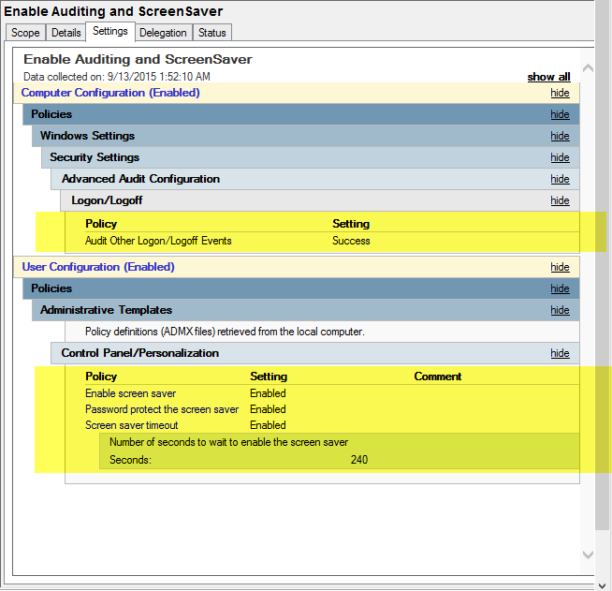

1. Copy all the files from \Project\castellan\config\nxlog configuration\shares\ to your Distributed File System. (Preparation to deploy Nxlog to the client computer)
2. Create a Member Server and run the Elasticsearch instances before deploying the NxLog to the client.
3. Follow the Group Policy Order. Ignore the Enable Audit Other Logon/Logoff Event and Screen Saver Settings if those policies are already in place.

